The

Diamond Speaking Series

Web site: www.JenniferCarroll.com

Email: info@JenniferCarroll.com

Selecting

Your Series

with

**Jennifer Carroll**

former Lieutenant Governor

Author

***“When You Get There”***

Choose the right series to motivate your audience!

Each series is targeted towards diverse audiences with different goals.

To select the right series for your audience or engagement, please feel free to contact us.

*Pressure Makes the Diamond*

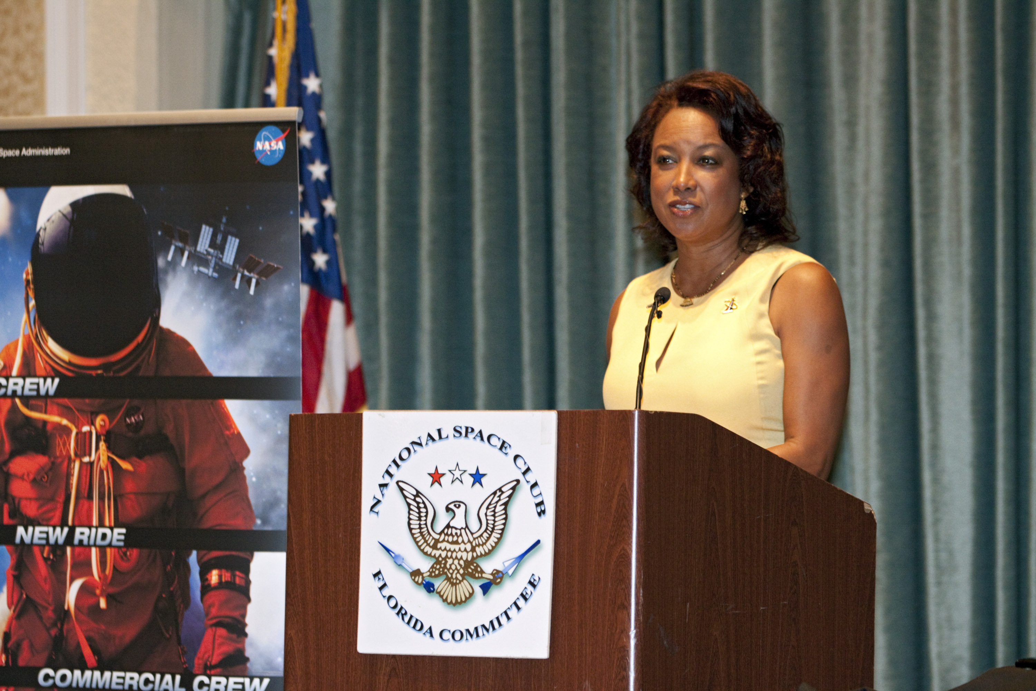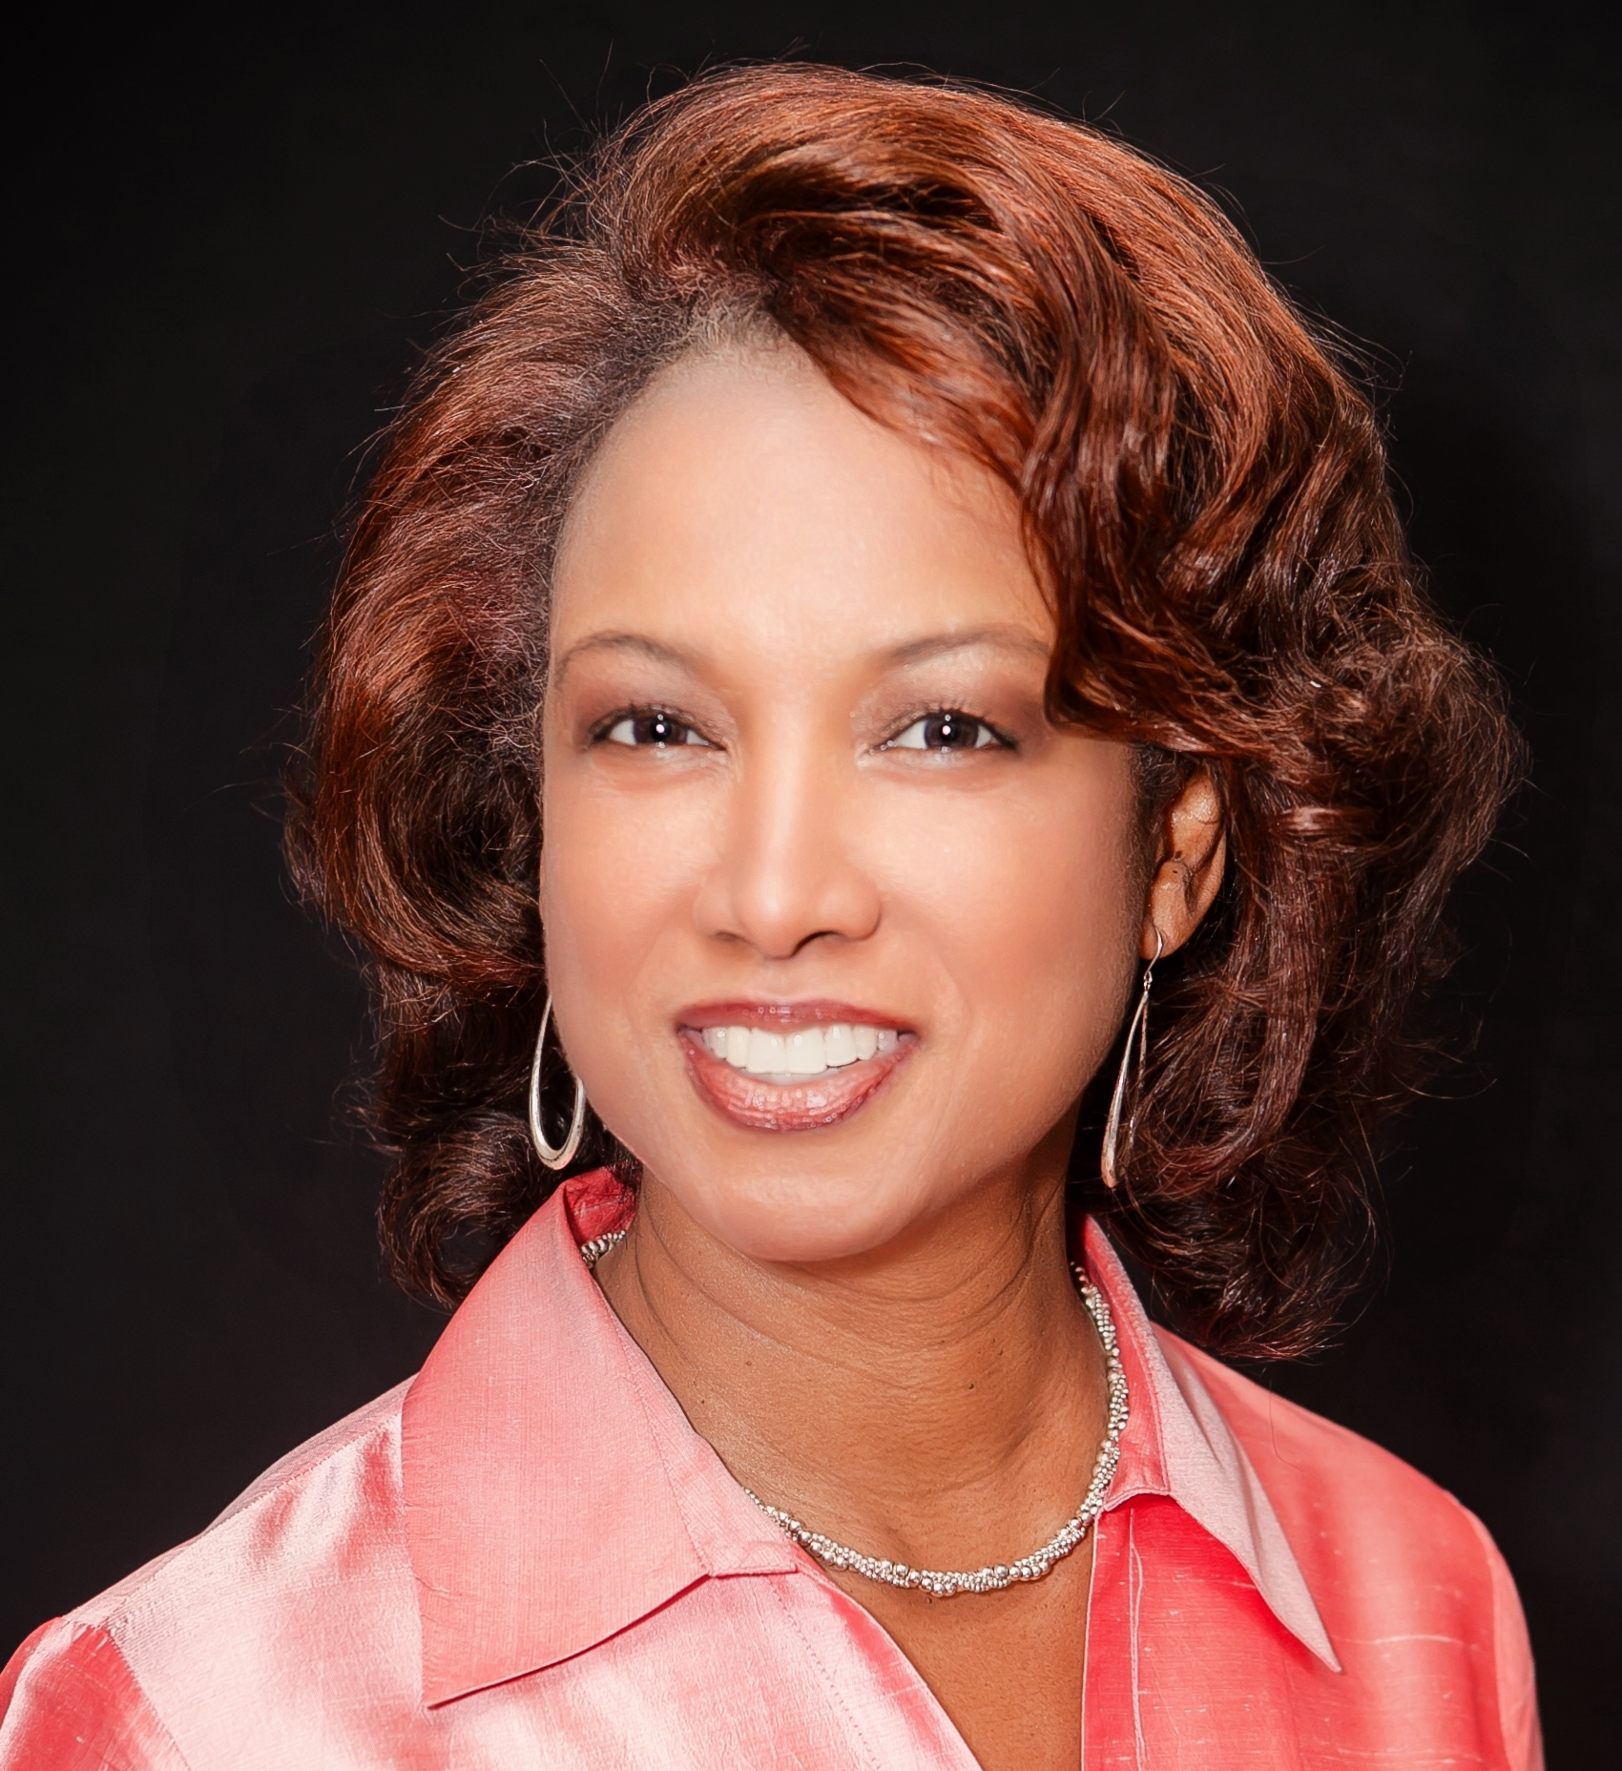

*Jennifer communicates timely information in a way that is realistic and easy to understand as well as inspirational. -Matt Justice, President Reliant Florida, LLC*

*Jennifer has a special gift of encouragement to others, backed by a life full of service, both in her military career and her political career! Outstanding speaker! Her passion inspires one to pursue life and to embrace the freedoms we enjoy and to use our gifts and talents to help others. -Kathy Davenport, Realtor, Berkshire Hathaway HS Florida Network Realty*

*She is one of the most dynamic speakers and hardest working ladies that I had the pleasure to meet. Jennifer can motivate a room in seconds. -Sharon B. Light, President Republican Women’s Club*

*Her presentation was straight forward, filled with enthusiasm, articulated in such a manner that it stirred the emotions and stimulated the interest of those present at this political gathering. -George R. Jackow Sr. Former Chairman of the Republican Party Osceola*

*Jennifer by far is the most eloquent, articulate, and intelligent professionals I have met. She is very good at grasping the overall purpose of an event and does a beautiful job tailoring her remarks to suit. -Gedone Prachar Baker Women’s Network*

# Diamonds In The Workplace

The most important information for those in the workforce, both men and women, is discussed in this series. Diamonds in the workplace was designed to help interact with business individuals who are stuck at a particular crossroad and need motivation to seek the right path.

# Diamonds Days

The series is targeted toward moments in time. Black History, Women's History, Memorial, or Veterans Day.

# Diamonds Under Pressure: Anything Is Possible

This is for the employee, management, parents and adults, as well as young women. This series allows confidence building during the trails of life.

# Diamonds Among Us Series

This series is specifically geared towards women’s conferences, veterans and parents. My words of enlightenment can help these diamonds among us, realize their inner strengths and how to use them reach their fullest potential.

# Diamonds In Industry

Diamonds in the Industry speaking series was created for the individuals who are currently in the industry of business, military or trade, who would like to improve efficiency and productivity by improving leadership, creativity and business skills.

*“I designed these series to be inspiring, motivating and uplifting. I truly believe with those components, anything is possible for those who want to do better.”-Jennifer Carroll*

Contact UsEmail: info@JenniferCarroll.comVisit us on the web:   
www.JenniferCarroll.com

# Speaking Points

• Defense * Military *Veterans

• Women * Women in the Workplace

• Space and Aerospace

• Leadership * Business * Trade

• Parenting

• Inspirational * Spiritual

• Motivating your

Employees

• Diversity

• Balancing Life

• Politics * Government

